**[使用 InstallShield 安装和卸载SQL Server 数据库](http://www.cnblogs.com/BeyondTechnology/archive/2010/10/14/1851672.html)**

本文主要介绍使用Installshield 进行数据库的安装和卸载，并在InstallShield 11.5 Premier Edition 和Installshield 12 Premier Edition 环境中测试通过。

**1、打开“SQL Scripts view”**，如图1

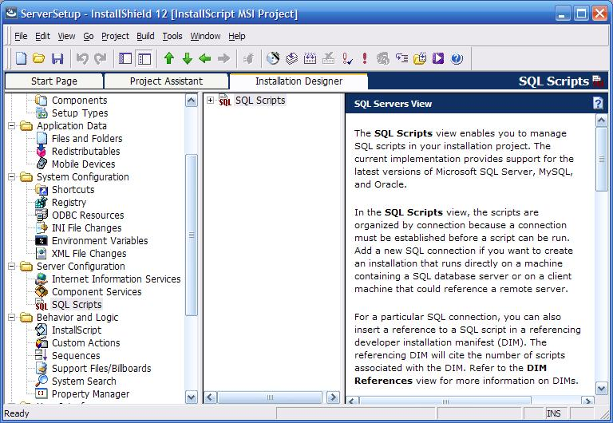

　　　　　　　　　　　　　　　　图1.  打开SQL Script View 视图

**2、建立一个连接，假定为“MasterConnection”，按照图2和图3设置该连接的属性。**

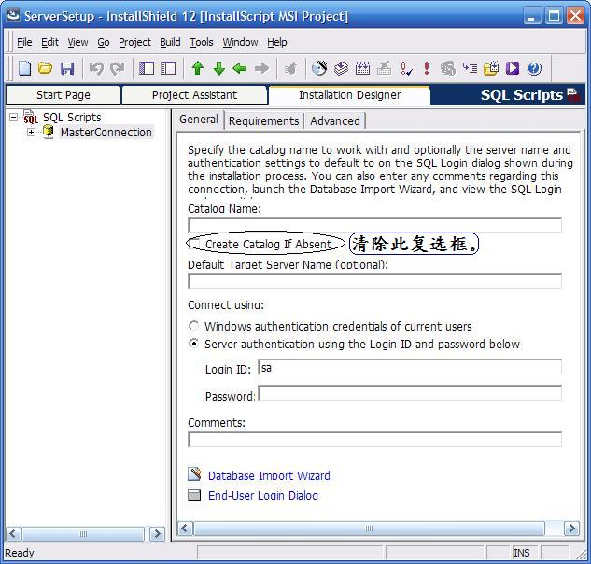

　　　　　　　　　　　　　　　　　　图2 建立连接  
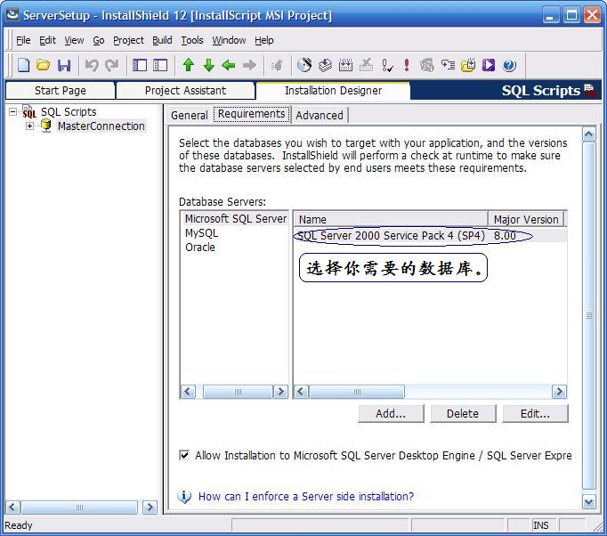

　　　　　　　　　　　　　　　　　　　　图3 设置连接的属性

**3、在“MasterConnection”下，新建一个Script，属性的设置如图4**，script 的内容如下：

 1 USE master  
 2   
 3 IF NOT EXISTS (SELECT *   
 4   
 5           FROM   master.dbo.sysdatabases   
 6   
 7           WHERE name = 'RelayBookkeeping')  
 8   
 9        CREATE DATABASE 'RelayBookkeeping'  
10   
11 GO  
12

注：RelayBookkeeping是我们需要创建的数据库。

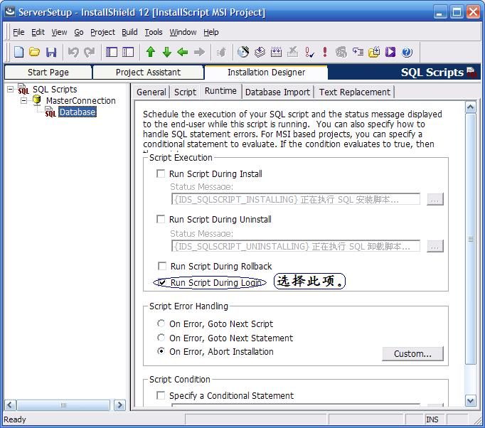

　　　　　　　　　　　　　　　　　　图4 新建一个Script

**4、新建连接“RelayBookkeepingConnection”，按照图5设置General属性。Requirements属性的设置参照图3的一样。**

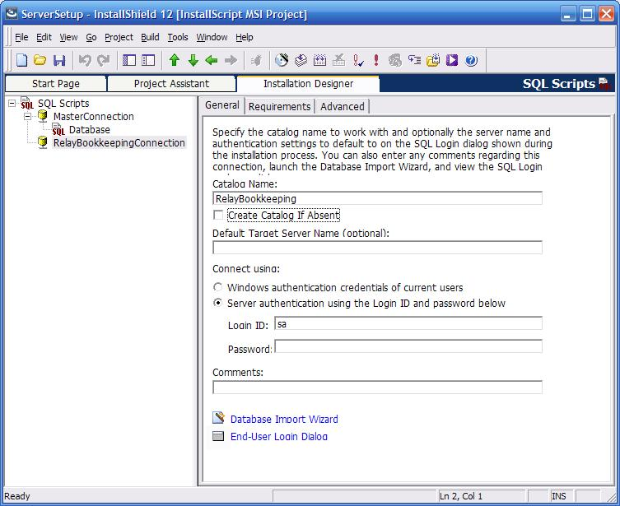

**图5 设置连接的属性**

**5、在“RelayBookkeepingConnection”下，新建你自己的数据库脚本。如图6。**

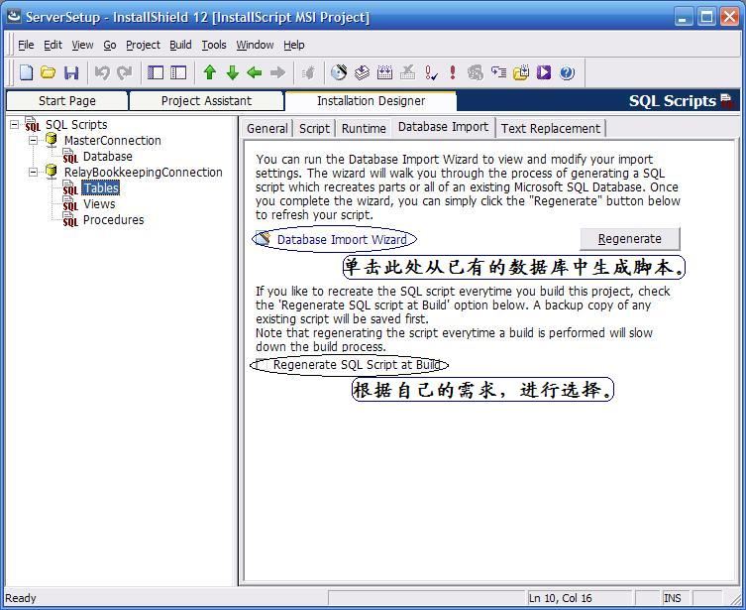

**图6 添加自己的数据库脚本**

**6、卸载程序时删除数据库。**

操作方法和和新建数据库（步骤1，2，3）类似。建立一个连接，General 属性页中，设置数据库名为Master。然后添加一个Script文件，Runtime属性设置为卸载时，内容为：

USE Master   
  
DROP DATABASE RelayBookkeeping  
  
GO

以下是在帮助里看到的,一篇是安装SQL Server的，一篇是ORACLE的。

 ------------------------------------------------------------------------------------------------------------------------------------------------

　　　　　　Creating a Sample Project that Will Create a SQL Server Catalog by Running Customized SQL Script

TASK

The following describes how to create a sample project that will create a SQL Server catalog on the target machine by running customized SQL script:

1.Create a new InstallShield project.

2.Go to the **Property Manager** view.

3.Create a new property named "IS_SQLSERVER_DATABASE2".

4.Go to the **SQL Scripts** view.

5.Create a new connection and call it "NewConnection1".

6.Click NewConnection1 in the explorer, and select the General tab.

7.Specify "TESTSQLSERVER" as the Target Server Name, and clear the **Create Catalog If Absent** option.

8.Select the **Server Authentication** option and specify "sa" as the **Login ID** and leave the **Password** field blank.

9.Click the **Requirements** tab.

10.Select the SQL Server check box and clear the Oracle and MySQL check boxes as the target databases.

11.Right-click **NewConnection1** in the explorer, and choose **New Script**.

12.Rename the new script "NewScript1".

13.Select **NewScript1** in the explorer, and click the **Script** tab.

14.Add the following script:

CREATE DATABASE [TestDB]  ON (NAME = N' TestDB', FILENAME =

　　　 N'C:\Program Files\Microsoft SQL Server\MSSQL\data\testdb.mdf' ,

　　   SIZE = 3, FILEGROWTH = 10%) LOG ON (NAME = N' TestDB_log', FILENAME

　　    = N'C:\Program Files\Microsoft SQL Server\MSSQL\data\testdb.ldf' ,

　　　 SIZE = 1, FILEGROWTH = 10%)

COLLATE SQL_Latin1_General_CP1_CI_AS

15.Click the **Runtime** tab, select **Run Script During Login**, and then clear the other script execution options.

16.Create a new connection in the **SQL Scripts** view, and call it "NewConnection2".

17.Click **NewConnection2** in the explorer, and select the **Advanced** tab.

18.From the **Target Catalog Property Name**box, choose IS_SQLSERVER_DATABASE2.

19.Click the **General** tab.

20.Specify "TESTSQLSERVER" as the Target Server Name and "TestDB" as the Catalog Name, and then clear the **Create Catalog If Absent** option.

21.Select the **Server Authentication** option and specify "sa" as the **Login ID** and leave the **Password** field blank.

22.Click the **Requirements** tab.

23.Select the **SQL Server** check box and clear the **Oracle** and **MySQL** check boxes as the target databases.

24.Right-click **NewConnection2** in the explorer, and choose**New Script**.

25.Rename the new script "NewScript2".

26.Select **NewScript2** in the explorer, and click the **Script** tab.

27.Add the following script:

　　CREATE TABLE TestTable (TestColumn1 CHAR NOT NULL PRIMARY KEY)

28.Click the Runtime tab, select Run Script During Install, and then clear the other script execution options.

 ------------------------------------------------------------------------------------------------------------------------------------------------

　　　　　　Creating a Sample Project that Will Create an Oracle Catalog by Running Customized SQL Script

TASK

The following describes how to create a sample project that will create an Oracle catalog on the target machine by running customized SQL script:

1.Create a new InstallShield project.

2.Go to the **Property Manager** view.

3.Create a new property named "IS_SQLSERVER_DATABASE2".

4.Go to the **SQL Scripts** view.

5.Create a new connection and call it "NewConnection1".

6.Click **NewConnection1** in the explorer, and select the **General** tab.

7.Specify "//sch01jsmith.macrvision.com:1521/orcl" as the Target Server Name, and clear the **Create Catalog If Absent** option.

8.Select the **Server Authentication** option and specify "Scott" as the login ID and "Scott" as the password.

9.Click the **Requirements** tab.

10.Select the **Oracle** check box and clear the **SQL Server** and **MySQL** check boxes as the target databases.

11.Right-click **NewConnection1** in the explorer, and choose **New Script**.

12.Rename the new script "NewScript1".

13.Select **NewScript1** in the explorer, and click the **Script** tab.

14.Add the following script:

CREATE TABLESPACE TEST_TS LOGGING DATAFILE ' /muddle/oracle/sts/ test01.dbf ' SIZE 64K AUTOEXTEND ON NEXT 2M MAXSIZE UNLIMITED

Go

CREATE USER TEST_USER IDENTIFIED BY MYPSWD DEFAULT TABLESPACE TEST_TS QUOTA UNLIMITED on TEST_TS

Go

GRANT CONNECT TO TEST_USER

Go

GRANT DBA TO TEST_USER

Go

ALTER USER TEST_USER DEFAULT ROLE ALL

Go

15.Click the **Runtime** tab, select **Run Script During Login**, and then clear the other script execution options.

16.Create a new connection in the **SQL Scripts** view, and call it "NewConnection2".

17.Click **NewConnection2** in the explorer, and select the **Advanced** tab.

18.From the **Target Catalog Property Name** box, choose IS_SQLSERVER_DATABASE2.

19.Click the **General** tab.

20.Specify "//sch01jsmith.macrvision.com:1521/orcl" as the Target Server Name and "TEST_USER" as the Catalog Name, and then clear the **Create Catalog If Absent option**.

21.Select the **Server Authentication**option and specify "TEST_USER" as the Login ID and "MYPSWD" as the password.

22.Click the **Requirements** tab.

23.Select the **Oracle** check box and clear the **SQL Server** and **MySQL** check boxes as the target databases.

24.Right-click **NewConnection2** in the explorer, and choose **New Script**.

25.Rename the new script "NewScript2".

26.Select NewScript2 in the explorer, and click the Script tab.

27.Add the following script:

CREATE TABLE TestTable (TestColumn1 CHAR NOT NULL PRIMARY KEY)

28.Click the **Runtime** tab, select **Run Script During Install**, and then clear the other script execution options.

分类: [InstallShield2008](http://www.cnblogs.com/BeyondTechnology/category/265153.html)